**SMART HOME USING TINKERCAD**

**CIRCUIT DIAGRAM:**

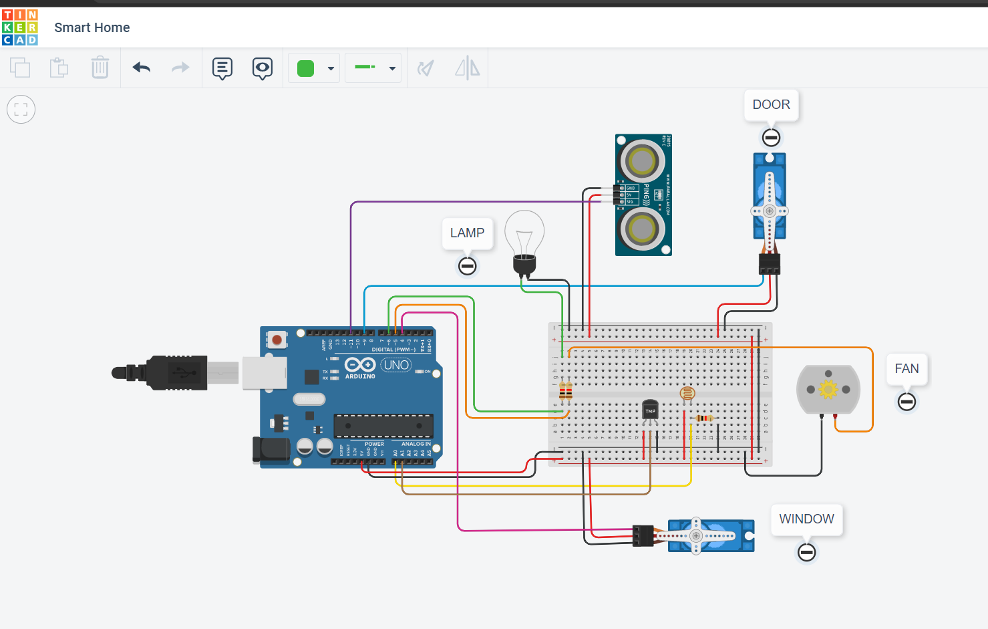

**COMPONENTS REQUIRED**:

*ARDUINO UNO

*BREADBOARD

*TEMPERATURE SENSOR

*ULTRASONIC SENSOR

*PHOTO RESISTOR

*DC MOTOR

*SERVO MOTOR

*BULB

**WORKING:**

The sensors connected to the microcontroller board are Ultrasonic and temperature sensors. The Ultrasonic sensor is used to automatically open the front door if someone is in front of the door. LDR is used for automatic light control in the home if someone is in the home at night the bulb is automatically turned ON and in the daytime, it is automatically turned OFF.

**CODE:**

#include <Servo.h>

const int light = 6;

int DistanceValue = 0;

int LDRValue = 0;

double temp;

int tempin = A1;

#define fan 5

long readUltrasonicDistance(int triggerPin, int echoPin)

{

pinMode(triggerPin, OUTPUT);

digitalWrite(triggerPin, LOW);

delayMicroseconds(2);

digitalWrite(triggerPin, HIGH);

delayMicroseconds(10);

digitalWrite(triggerPin, LOW);

pinMode(echoPin, INPUT);

return pulseIn(echoPin, HIGH);

}

Servo servo_4;

Servo servo_9;

void setup()

{

pinMode (fan,OUTPUT);

pinMode(light, OUTPUT);

pinMode(A0, INPUT);

servo_4.attach(4, 500, 2500);

servo_9.attach(9, 500, 2500);

}

void loop()

{

temp = 0;

temp =analogRead(tempin);

temp = (double)temp/1024;

temp = temp * 5;

temp = temp - 0.5;

temp = temp * 100;

if (temp <20) {

analogWrite(fan,0);

}

else if (temp<=20) {

analogWrite(fan, 51);

}

else if (temp<=25) {

analogWrite( fan,102);

}

else if (temp<=30) {

analogWrite (fan,153);

}

else if (temp<=49) {

analogWrite(fan,200);

}

else if (temp>=50) {

analogWrite(fan,255);

}

DistanceValue = 0.01723 * readUltrasonicDistance(11, 11);

LDRValue = analogRead(A0);

if (LDRValue >= 550) {

servo_4.write(90);

analogWrite(light,0);

}

else {

servo_4.write(0);

analogWrite(light,255);

}

if (DistanceValue <= 300) {

servo_9.write(90);

delay(100);

}

else {

servo_9.write(0);

delay(100);

}

}

**OUTPUT:**

